Date: December 28, 2022
To: Weber County Board of County Commissioners
From: Ronna Tidwell
Agenda Date: January 3, 2023
Subject: Request to Declare Parcel Number 15-132-0012 as Surplus Property
Attachments: A - Aerial Vicinity Map
B - Ownership Plat

_____________________________________________________________________________________

Summary:
A Weber County owned parcel of land, identified as Tax ID #15-132-0012, was acquired by the County through a tax sale process and deed executed in 1988. The parcel contains approximately .28 acres and is located at the end of the cul-de-sac of 2050 W in West Haven. See Attachment A for a vicinity map and Attachment B for the County Recorder’s ownership plat map.
The County has been contacted by an adjacent property owner who has asked if the County would consider selling the subject parcel.
Weber County has no intended use for this property; therefore, it is recommended that the parcel be declared as surplus and offered to the adjacent property owner(s). In order to convey real property, the County Commission must first take action to declare this parcel as surplus property.

Property Description:

15-132-0012

A HOLDING POND IN CIRCLE "R" INDUSTRIAL PARK SUBDIVISION, WEST HAVEN CITY, WEBER COUNTY, UTAH, DESCRIBED AS FOLLOWS: BEGINNING AT THE NORTHEAST CORNER OF SAID SUBDIVISION, RUNNING THENCE WEST 210.46 FEET, THENCE SOUTH 52D55' WEST 82.92 FEET, THENCE EAST 276.14 FEET, THENCE NORTH 0D32'30"EAST 50.00 FEET TO THE PLACE OF BEGINNING.

Attachment A
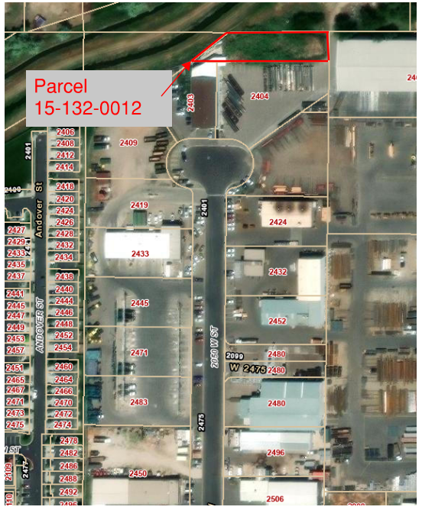

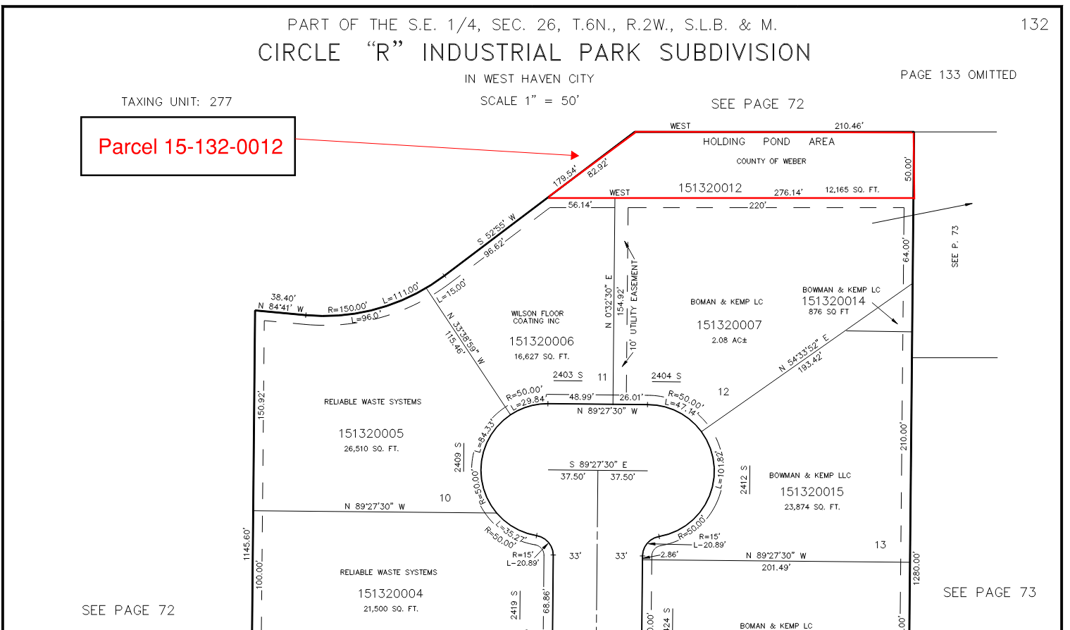
Attachment B

